Homework 5 UML design

Chimzim Ogbondah

SE 319

Nov. 11 2020

Part 1)

Part 2)

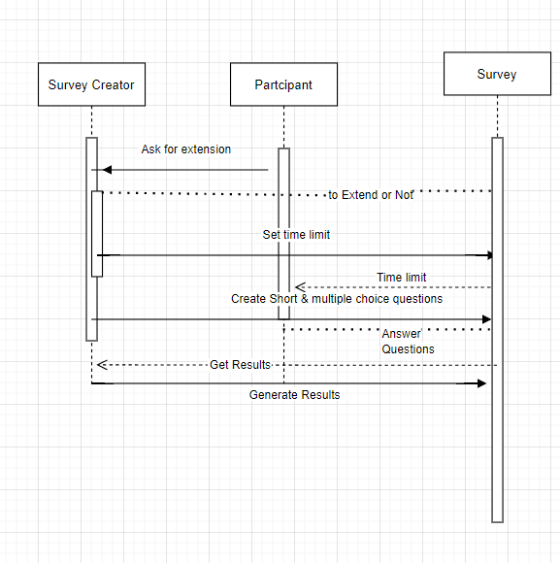

Part 3)

